**Karan Arora**  **R.L. Institute M: 9416974837**

**Max Time : 1 ½ hr** **Class = 12th Biology Test**  **Max Marks : 40**

**Ecology**

1. Multiple choice questions : [ 1 X 10 = 10]
2. Which of the following is not included in the biodiversity hotspots of India?

|  |  |  |  |
| --- | --- | --- | --- |
| a) Western Ghats | b) Himalayas | c) Indo-Burma | d) North Indian Plains |

1. If the energy produced at the level of producers is 1000 J, the energy available for the secondary consumers is:

|  |  |  |  |
| --- | --- | --- | --- |
| a) 1000 J | b) 100 J | c) 10 J | d) 1 J |

1. Competition for light, nutrient and space is most severe between :

|  |  |
| --- | --- |
| a) closely related organisms growing in different niches. | b) closely related organisms growing in same niches |
| c) distantly related organisms growing in same habitat | d) distantly related organisms growing in different habitat |

1. Food chain in which microorganisms break down the dead organic matter is :

|  |  |  |  |
| --- | --- | --- | --- |
| a) parasitic food chain | b) detritus food chain | c) consumer food chain | d) predator food chain |

1. What type of ecological pyramid would be obtained with the following data?

Secondary consumer = 120 g

Primary consumer = 60 g

primary producer = 10 g

|  |  |
| --- | --- |
| a) Inverted pyramid of biomass | b) Pyramid of energy |
| c) upright pyramid of numbers | d) upright pyramid of biomass |

1. One of the ex situ conservation methods for endangered species is :

|  |  |  |  |
| --- | --- | --- | --- |
| a) wildlife sanctuaries | b) Biosphere reserve | c) Cryopreservation | d) National park |

1. In a population of 500 zebras, average natality is 25 , average mortality is 20 , immigration is 30 and emigration is 35. what will be the population at the end of 10 years?

|  |  |  |  |
| --- | --- | --- | --- |
| a) 550 | b) 600 | c) 650 | d) 500 |

1. An urn shaped population age pyramid represents:

|  |  |  |  |
| --- | --- | --- | --- |
| a) growing population | b) static population | c) declining population | d) extinct population |

1. Edaphic factor refers to :

|  |  |  |  |
| --- | --- | --- | --- |
| a) water | b) soil | c) relative humidity | d) altitude |

1. The historic convention on biological diversity held in Rio de janeiro in 1992 is known as :

|  |  |  |  |
| --- | --- | --- | --- |
| a) CITES convention | b) The Earth Summit | c) G-16 Summit | d) MAB programme |

1. What are ectotherms? [ 1 ]
2. Define Allen’s rule? [ 1 ]
3. How is ‘stratification’ represented in a forest ecosystem? [ 1 ]
4. What are seed banks? [ 1 ]
5. Two different types of population growth curves are used to measure population density. Study the two growth curves and answer the corresponding questions. [ 2 ]

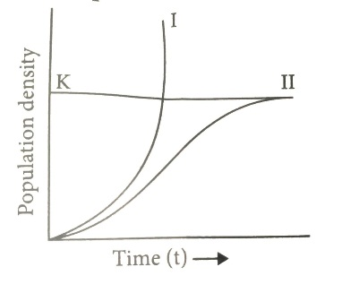

A forest having unlimited food resources hardly has any carnivores. Identify the curve that will explain the population growth of herbivores in that forest. Also give the equation representing the graph.

1. Write the relationship between productivity, gross primary productivity, net primary productivity and secondary productivity. [ 2 ]
2. State Gause’s competition exclusion principle. [ 2 ]
3. Differentiate between in situ and ex situ approaches of conservation of biodiversity. [ 2 ]
4. Name and describe any three causes of biodiversity losses. [ 3 ]
5. (a) Explain ‘Birth rate’ in a population by taking a suitable example. [ 3 ]

(b) Write the other two characteristics which only a population shows but an individual cannot.

1. (i) How does our body adapt to low oxygen availability at high altitudes? [ 3 ]

(ii) How does a desert plant adapt to the dry, warmer environmental conditions?

1. Outline salient features of carbon cycling in an ecosystem. [ 3 ]
2. Write any three hypotheses put forth by ecologists explaining the existence of greater biodiversity in tropical regions than in temperate regions. [ 3 ]
3. Differentiate between mutualism, parasitism and commensalism . Provide one example of each. [ 3 ]